**Module-1**

**QUE** 1 • What is SDLC?

-A Software Development Life Cycle Is Essentially A Series Of Steps Or Phases That Provides A Model For The Development And Lifecycle Management Of An Application Or Pieces Of Software

**QUE** 2 • What is software testing?

-Testing Is the Process of Evaluating A System of Its Components with the Intent to Find That Whether its Satisfies the Specified Requirement or Not

-Software Testing Is a Process Used To Identify the Correctness, Completeness and Quality of Developed Computer Software

**QUE** 3 • What is agile methodology?

-It Is a Combination Iterative and Increment Model

-it divides the Software into Small Inorerrevit Build Are Provided in Herations that Means the Big Projects Are Divided in Small Chunks

-Agile model believes that every project needs to be handled differently and the existing methods need to be tailored to best suit the project requirements. In agile the tasks are divided to time boxes (small time frames) to deliver specific features for a release.

**QUE** 4 • What is SRS?

-SRS Is a Complete Description of an Application Which Is To Be Developed

-SRS Contains Use Case Diagram That Describes All the Interactions User Will Have with the Software Application

**QUE** 5 • What is oops?

-Object Oriented Programing is Way of Writing the Program in Organized Way Objects Are like a Black Box Where Data Are Hidden

**QUE** 6 • Write Basic Concepts of oops?

-Class

-Objects

-Inheritance

-Polymorphism

1. Over Riding

2. Over loading

-Encapsulation

-Abstraction

**QUE** 7 • What is object?

-Object Gives the Permission to Access Functionally of class

**QUE 8** • What is class?

-Class Is A Collections of Data Member And Member Function

**QUE 9** • What is encapsulation?

-The Process warping the data in a single unit to secure The data from outside World

**QUE 10** • What is inheritance?

-Making A class from an existing class deriving the attribute of same other class

**QUE 11** • What is polymorphism?

-One name multiple Form

**QUE 12** • Draw Use case on online book shopping

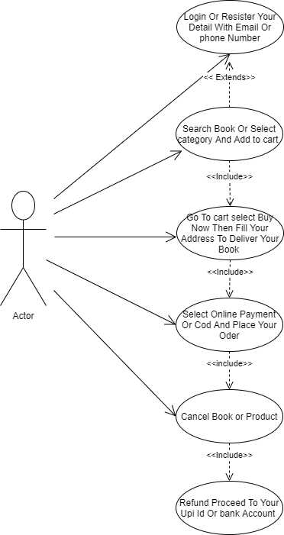

**QUE 13** • Draw Use case on online bill payment system (paytm)

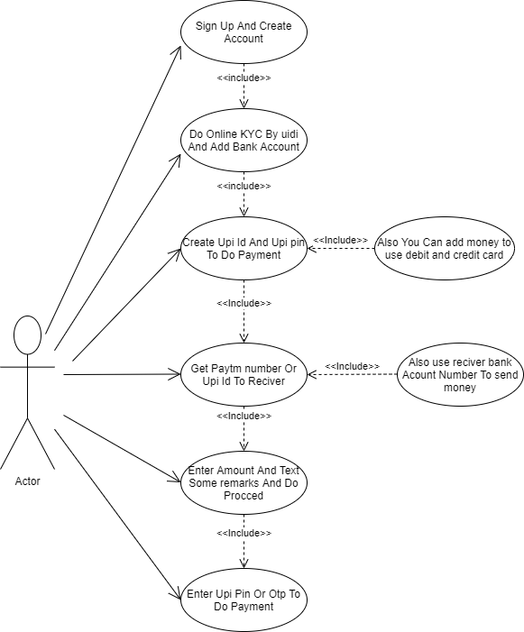

**QUE 14** • Write SDLC phases with basic introduction

-Requirement collection/gathering:-Establish customer Needs

-Analysis:-Model and specify the requirements-“what”

-Design:- Model and specify a solution-“why”

-Implementation:- Construct a solution in software

-Testing:- Validate the solution against the Requirements

-Maintenance:- Repair Defects And Adopt the solution to the new requirements

**QUE 15** • Explain Phases of the waterfall model

-Requirement collection

-Analysis

-Design

-Implementation

-Testing

-Maintenance

**Note:-** Waterfall Model phases same As SDLC phases

**QUE 16** • Write phases of spiral model

-Planning:-Determination of Objective Alternatives and Constants

-Risk Analysis: - Analysis of Alternatives and identification/resolution of risks

- Customer Evaluation: - Assessment of the results of Engineering

-Engineering: - Development of the “next level” Product

**QUE 17** • Explain working methodology of agile model and also write pros and cons

-It is a Combination iterative and increment Model

-It divides the software into small increment build are provided in iterations that means the big projects are divided in small chunks

-Each iteration last about one to three weeks

-After the realise we check for the feedback of the developed software

-If any enhancement is needed in the projects then it’s done and its release and re-release

**Pros**

**-**Frequent Delivery

-Face to face Communication with Customer

-Less Time

-Adaptability

**Cons**

-Less Documentation

- Maintenance Problem

**QUE 18** • Draw use case on Online shopping product using COD.

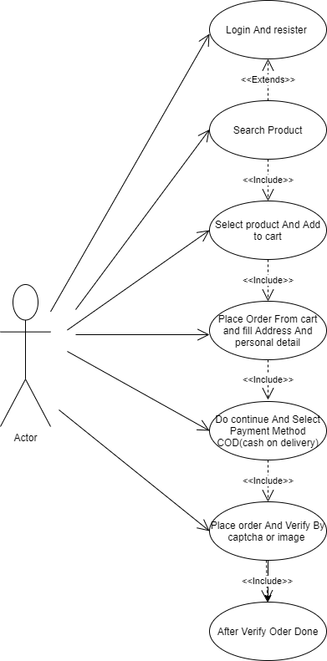

**QUE 19** • Draw use case on Online shopping product using payment gateway.

